# ACTIVITY 05

## Question 1:

**Now create destination table (MSSQL data warehouse) with following columns**

**PID                  Primary Key (auto generated)**

**TimeStamp      Time on which ETL process started**

**Destination Table Attributes**

**PID, TimeStamp, id, firstname, lastname, address and cellno**

# STEPS FOR ACTIVITY 5 QUESTION 1

1. USE THE SAME CSV FILES THAT WE USE IN THE ACTIVITY 4.
2. NOW CREATE 2 TABLES IN MYSQL AND INSERT DATA AS SHOWN BELOW USING THE SAME DATABASE activity04.
3. CREATE DATABASE TABLE FOR SSMS, ADD NEW ATTRIBUE PRIMARY KEY AS A NEW ATTRIBUTE (AUTO GENERATED).
4. OPEN VISUAL STUDIO AND COPY ACTIVITY4 PACKAGE AND RENAME IT for ACTIVITY5,NOW ADD ONE MORE ODBC SOURCE AND DATA CONVERSION, CONFIGURE IT AND LIKE WE DID IN ACTIVITY04 AND CONNECT IT WITH UNION ALL ALSO ADD SOURCE NAME AT DESTINATION WITH THE HELP OF SCRIPT AND DERIVED COLUMN.

### STEP 1

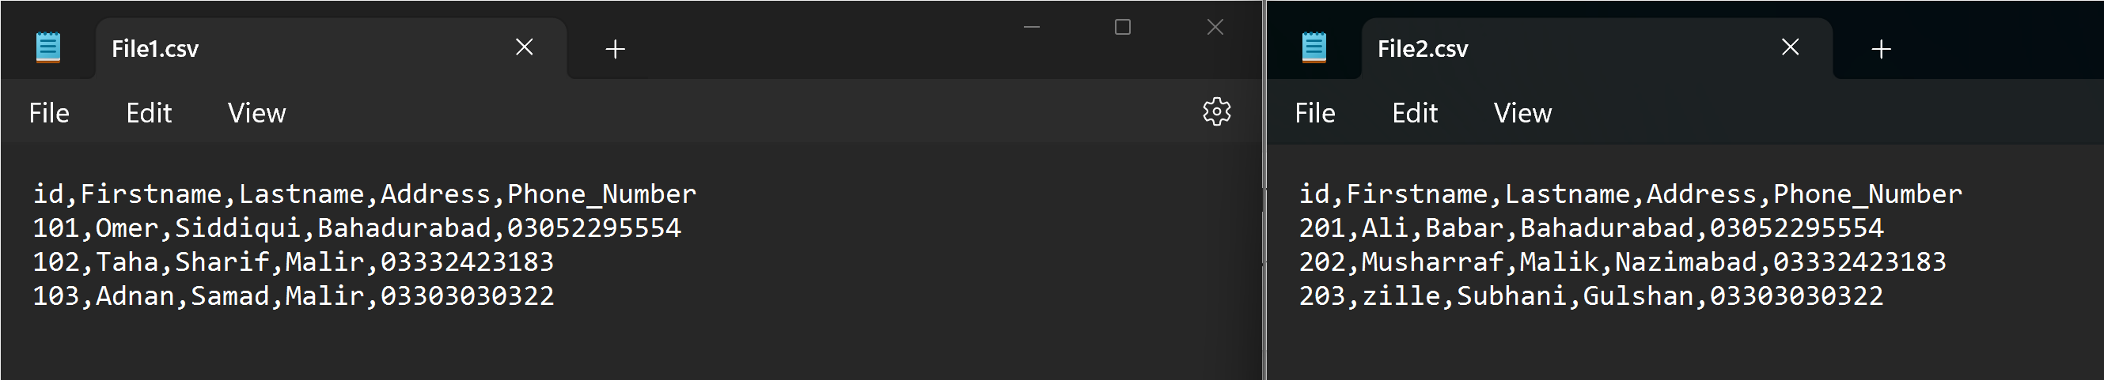

### STEP 2

-- create database DWass2;

use DWass2;

create table Activity4(

id int,

Firstname varchar(50),

Lastname varchar(50),

Address varchar(50),

Phone_Number varchar(11)

);

-- truncate table Activity4;

insert into Activity4(id,Firstname,Lastname,Address,Phone_Number) values(400,'BAig','Safdar','Bahadurabad','03052295554');

insert into Activity4(id,Firstname,Lastname,Address,Phone_Number) values(401,'Irfan','junejo','Gulshan','03052456443');

insert into Activity4(id,Firstname,Lastname,Address,Phone_Number) values(402,'Saad','Hussain','PIB','03003982773');

select * from Activity4;

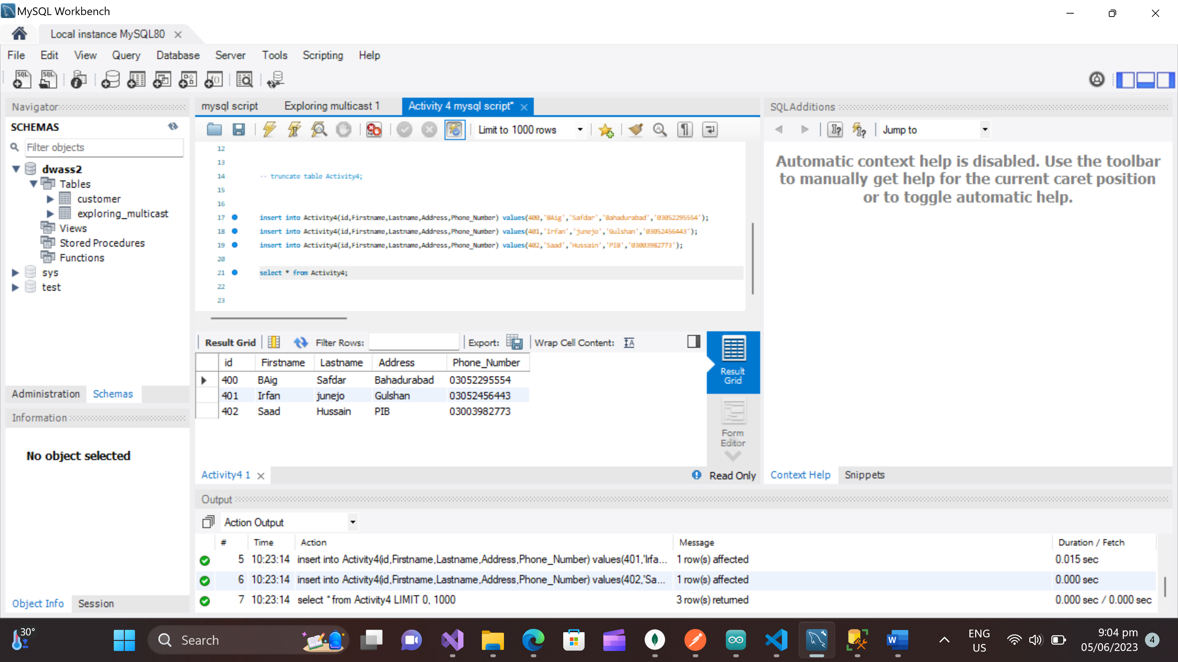

create database DWass2;

use DWass2;

create table Customer(

id int,

Firstname varchar(50),

Lastname varchar(50),

Address varchar(50),

Phone_Number varchar(11)

);

-- truncate table customer;

insert into customer(id,Firstname,Lastname,Address,Phone_Number) values(300,'Omer','Siddiqui','Bahadurabad','03052295554');

insert into customer(id,Firstname,Lastname,Address,Phone_Number) values(301,'Ahsan','Amir','Gulshan','03052456443');

insert into customer(id,Firstname,Lastname,Address,Phone_Number) values(302,'Faaiz','Faroqi','PIB','03003982773');

select * from customer;

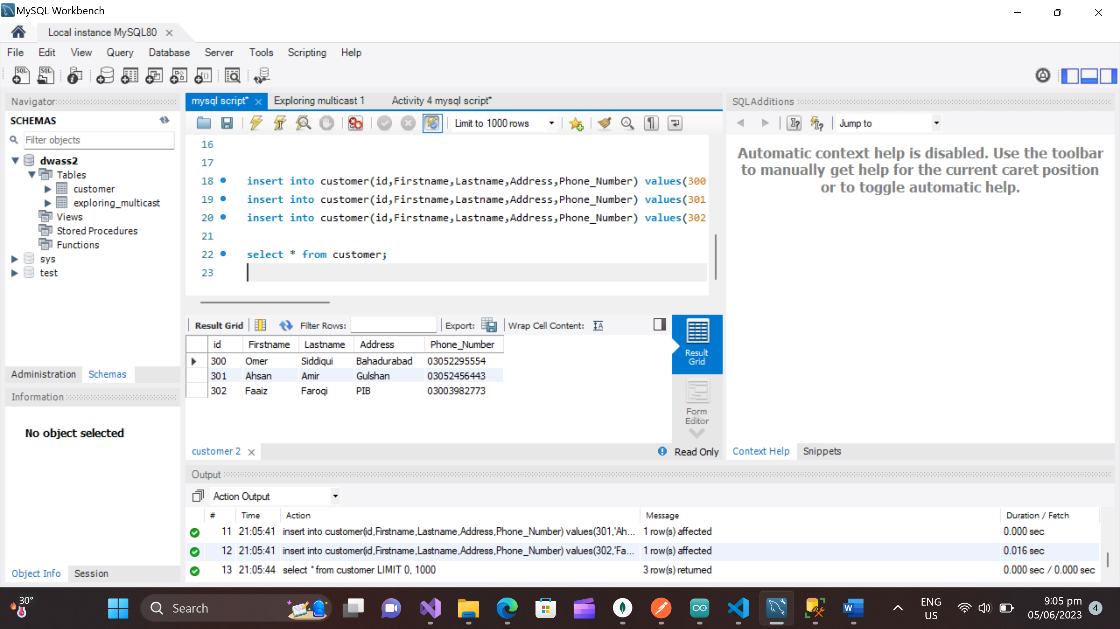

### STEP 3

--create database [DWH assignment];

use [DWH assignment ];

create table dbo.Customers(

pid int IDENTITY(1,1) PRIMARY KEY,

id int,

Firstname varchar(50),

Lastname varchar(50),

Address varchar(50),

Phone_Number varchar(11),

times datetime DEFAULT current_timestamp,

SourceName varchar(255)

);

select * from dbo.Customers;

-- truncate table dbo.Customers;

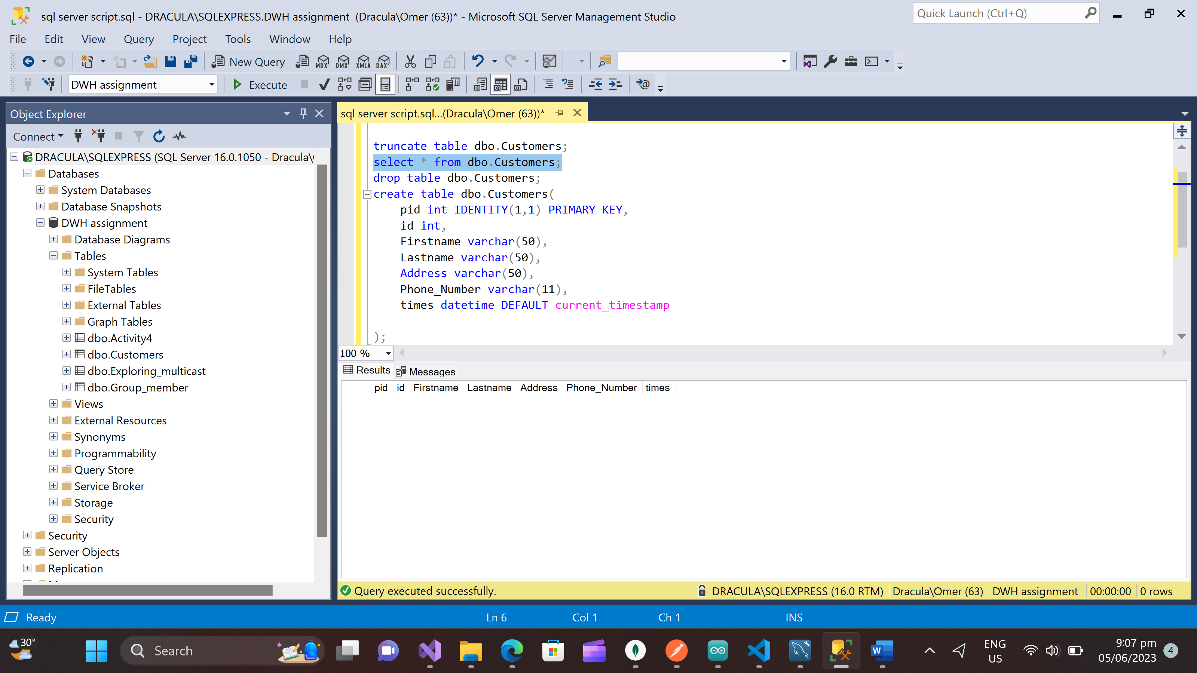

### STEP 4

